**Procedure SE16-download SAP data for**

**CSI Authorization Auditor**

Download tables with transaction **SE16**

* Please **ensure** that transaction **SE16** is used with the required settings and **not SE16N or SE16N in Batch mode**

**1) Verify the settings of the SE16 transaction (Settings / User parameters / Data Browser)**

* "Output List" = SE16 Standard List
* "Key Word" = FIELD NAME;
* "Maximum no. of hits" = “999999.999”
* "Width of output list" = 250

**2) Execute the downloads**

* Start SE16 transaction
* Key in table name
* Max records = ""
* Execute (or <F8>)
* WRITE DOWN THE TOTAL SELECTED RECORDS ON THIS FORM
* System/List/Save//Local File/UNCONVERTED
* C:\??????.UPL (?????? = Table name)
* Go to next table

|  |  |  |  |  |  |  |  |  |  |
| --- | --- | --- | --- | --- | --- | --- | --- | --- | --- |
| **Table Name** | **Description** | **3_XX** | **4_XX** | **4_0B** | **4_5B** | **4_6B** | **4_6C** | **WAS (4.7, ECC 6.0)** | **HANA** |
| AGR_AGRS | *Composite roles* |  |  |  |  | **X** | **X** | **X** | **X** |
| AGR_PROF | *Role – Profile* |  |  |  | **X** | **X** | **X** | **X** | **X** |
| AGR_TEXTS(*) | *Role Description* |  |  |  | **X** | **X** | **X** | **X** | **X** |
| AGR_USERS | *User – Role* |  |  |  | **X** | **X** | **X** | **X** | **X** |
| T000 | *Client Settings* | **X** | **X** | **X** | **X** | **X** | **X** | **X** | **X** |
| TOBJT(*) | *Description auth objects* | **X** | **X** | **X** | **X** | **X** | **X** | **X** | **X** |
| USR02 | *User id’s* | **X** | **X** | **X** | **X** | **X** | **X** | **X** | **X** |
| USR03 | *Description user-id’s* | **X** |  |  |  |  |  | **X** | **X** |
| USR11(*) | *Description profiles* | **X** | **X** | **X** | **X** | **X** | **X** | **X** | **X** |
| USR13(*) | *Description authorizations* | **X** | **X** | **X** | **X** | **X** | **X** | **X** | **X** |
| USREFUS | *Reference users* |  |  |  |  |  | **X** | **X** | **X** |
| UST04 | *User – Profiles* |  |  |  |  |  | **X** | **X** | **X** |
| UST10C | *Composite profiles* | **X** | **X** | **X** | **X** | **X** | **X** | **X** | **X** |
| UST10S | *Single profiles* | **X** | **X** | **X** | **X** | **X** | **X** | **X** | **X** |
| UST12 | *Authorization values* | **X** | **X** | **X** | **X** | **X** | **X** | **X** | **X** |
| V_USERNAME | *Description user-id’s* |  |  | **X** | **X** | **X** | **X** | **X** | **X** |
| AGR_1250 | *Auth. data for the activity group Table* |  |  |  |  |  |  | **X** | **X** |
| AGR_1251 | *Auth. data for the activity group Table* |  |  |  |  |  |  | **X** | **X** |
| AGR_1252 | *Org. elements for auth. information* |  |  |  |  |  |  | **X** | **X** |
| AGR_TCODES | *Assignment of roles to Tcodes* |  |  |  |  |  |  | **X** | **X** |
| AGR_1016B | *Name of the activity group profile* |  |  |  |  |  |  | **X** | **X** |
| AGR_DEFINE | *Role definition Table* |  |  |  |  |  |  | **X** | **X** |
| AGR_FLAGS | *Role attributes Table* |  |  |  |  |  |  | **X** | **X** |
| USORG | *Org Level Fields and Description* |  |  |  |  |  |  | **X** | **X** |

(*) Tables can be restricted to one language

|  |  |
| --- | --- |
| **Release** | **Description** |
| 3.XX | SAP Releases 3.0X or 3.1X |
| 4.XX | SAP Releases 4.XX (No user name, reference user and roles) |
| 4.0B | SAP Release 4.0B |
| 4.5B | SAP Release 4.5B |
| 4.6B | SAP Release 4.6B |
| 4.6C | SAP Releases 4.6C or 4.6D |
| WAS | SAP Releases 4.7, ECC 6.0, BW, CRM, …new ones |
| HANA | SAP S/4 HANA |

Additionally, please run reports RSPARAM and RSUSR003 and save them as text file (extension ‘.txt’).

**Preparations for extraction:**

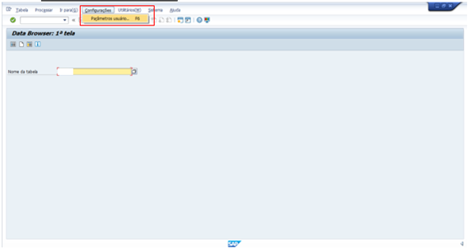

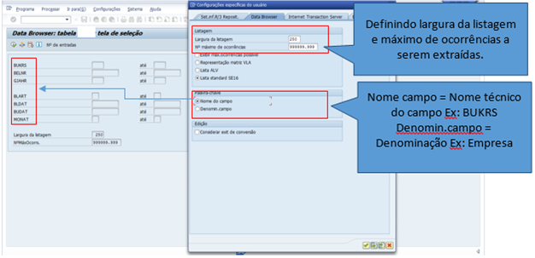

Defining list width and maximum occurrences to be extracted

Field name = field technical name

Selecting fields to be considered in the extraction (make sure before extracting each table that all fields are marked for extraction):

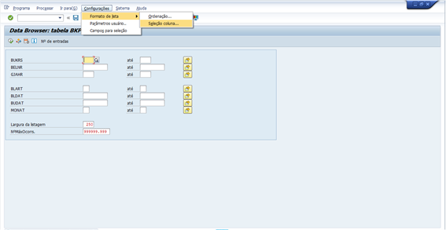

Ex:

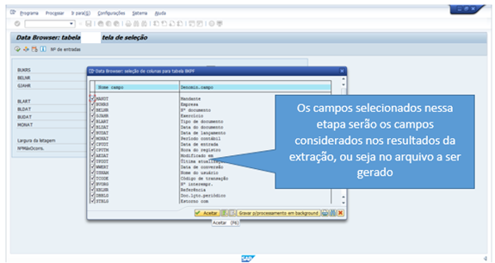

The fields selected in this step will be the fields considered in the extraction results.